**HALL of FAME**

**WISCONSIN ASA**

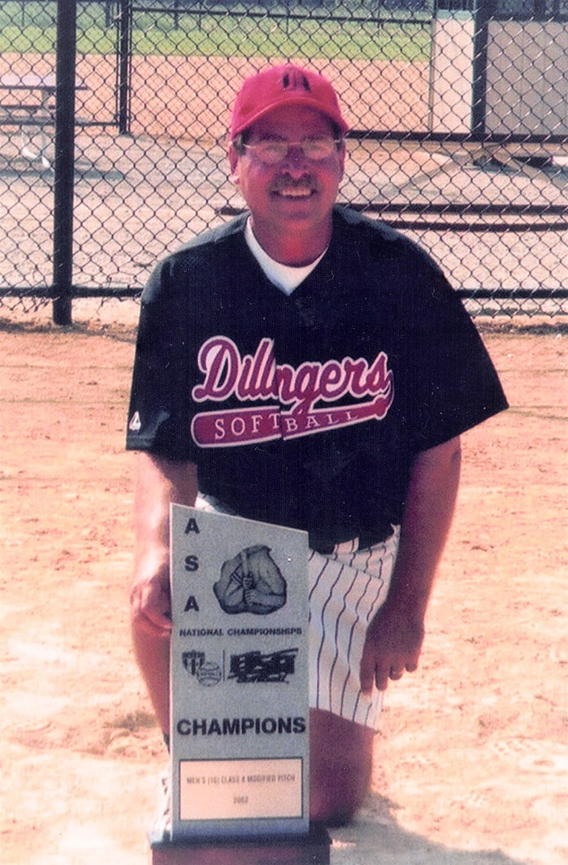

***Tom Rausch***

***Class of 2005***

***Fond du Lac, WI***

***Men’s Modified Pitch - Mgr***

***State Commissioner***

***Biography:***

Tom is one of the most successful managers in the history of Wisconsin ASA modified pitch softball. Started managing in 1983. Since then, his teams have achieved over 780 victories and captured more than 70 league and tournament championships while winning at an .800 clip.

He is the architect of Dillinger’s modified dynasty which has produced 10 WASA state titles in the last 11 years. He guided Sports Page to the WASA crown in 1994, then it became Dillinger’s and won in 1995 – 96. Dillinger’s has won the state championship each year starting with 1998 and seeks to extend the run in 2005. Dillinger’s has also won two ASA 10-man modified national championships (2002 and 2003) and had second place finishes in 1995 and 1998 plus a third place in 2001. They’ve had 11 top 10 finishes in 11 years in ASA national tournament play.

Tom’s adult playing career began in 1969 at the age of 16 in the Oakfield Fast Pitch League and he made the all-star team relying on his speed and bunting prowess. Manning right-centerfield most of his career, he played for 14 league champions in the powerful Fond du Lac American League from 1975-1993. In 1979 he played with the Roadhouse wrecking crew that compiled a gaudy 76-4 record and opened the season with 44 straight victories. He’s the only person in Fond du Lac recreation softball history to play on five league championship teams in one season (1990).

****Has been a member of the Fond du Lac Softball Board of Directors for 22 years, serving as president for four years. Elected to the Fond du Lac Hall of Fame as an inaugural member in 1999. WASA President from 1999-2002 and interim president in 2003-04. Appointed WASA Commissioner in 2015.